IC UM66
CP022
Image:
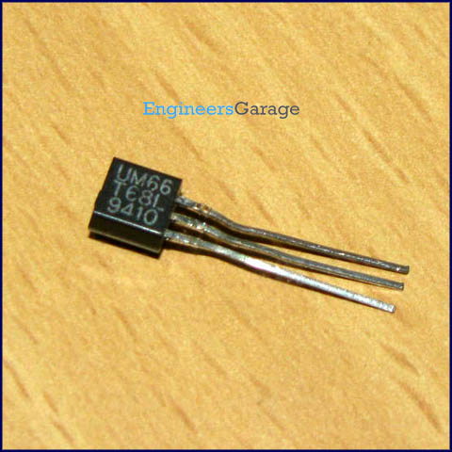
DataSheet:
UM66.pdf

UM66T is a melody integrated circuit. It is designed for use in bells, telephones, toys etc. It has an inbuilt tone and a beat generator. The tone generator is a programmed divider which produces certain frequencies. These frequencies are a factor of the oscillator frequency. The beat generator is also a programmed divider which contains 15 available beats. Four beats of these can be selected.

There is an inbuilt oscillator circuit that serves as a time base for beat and tone generator. It has a 62 notes ROM to play music. A set of 4 bits controls the scale code while 2 bits control the rhythm code. When power is turned on, the melody generator is reset and melody begins from the first note. The speaker can be driven by an external npn transistor connected to the output of UM66.

Many versions of UM66T are available which generate tone of different songs. For example, UM66T01 generates tone for songs ‘Jingle bells’, ‘Santa Claus is coming to town’ and ‘We wish you a merry X’mas’.

Pin Diagram:
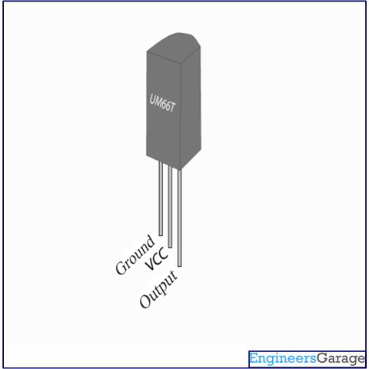
Pin Description:
Pin No | Function | Name
1 | Melody output | Output
2 | Supply voltage (1.5V - 4.5V) | Vcc
3 | Ground (0V) | Ground

